APJ ABDUL KALAM TECHNOLOGICAL UNIVERSITY
B.Tech Degree S6 (R, S) / S6 (PT) (R) Examination June 2023 (2019 Scheme)
Course Code: CST302
Course Name: COMPILER DESIGN
PART A
Answer all questions, each carries 3 marks.
- What is the relevance of input buffering in lexical analysis?
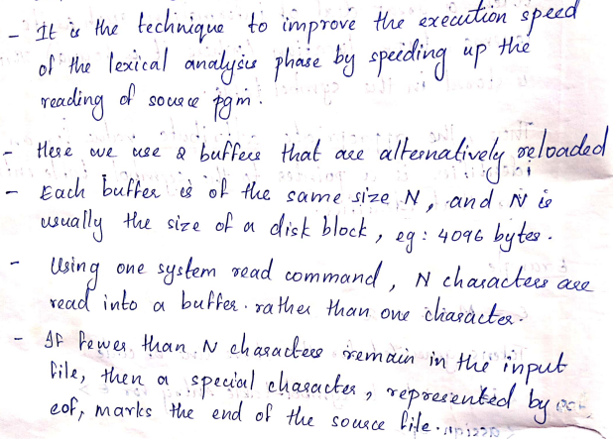

- Draw a transition diagram to represent relational operators.
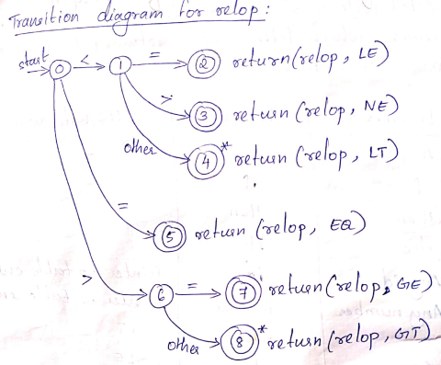
- With an example write the steps to remove left recursion.
Here is an example of a left-recursive grammar:
A -> A + B | B
B -> C * B | C
C -> (A) | id

The non-terminal symbol A can derive a string that starts with itself, for example, A => A + B => A + C * B => ..., creating an infinite loop.

To remove left recursion from a grammar, we can follow these steps:

Identify the left-recursive non-terminals.
For each left-recursive non-terminal A, create a new non-terminal A' and move all the productions of A that start with A to the new non-terminal A', replacing A with A' in the rest of the productions.
Thus the pair of production A→A α | β could be replaced by non-left recursive productions

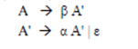
Without changing the strings derived from A.

- What is left factoring? Left factor the following grammar, C
E → E + T | T
T → float | float ∗ T | (E)
Left factoring is a grammar transformation that is useful for producing a grammar suitable for predictive parsing. The basic idea is that when it is not clear which of two alternative productions to use to expand a nonterminal “A”, we may be able to rewrite the “A” productions to refer the decision until we have seen enough of the input to make the right choice
After left factoring the grammar is,
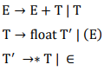
- Differentiate CLR and LALR parsers.
Comparison (any three) - 3 marks

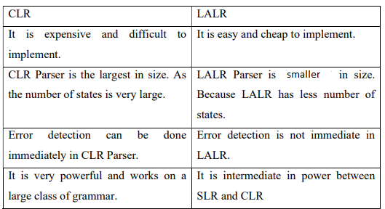
- What are the possible actions of a shift-reduce parser?
Actions – Shift, Reduce, Accept, Error - 1.5 marks
Explanation – 1.5 marks
Shift: This action pushes the next input symbol onto the stack and moves to the next input symbol. This is done when the parser encounters a terminal symbol that is not part of a completed handle.

Reduce: This action applies a grammar production to the top symbols on the stack, replacing them with a non-terminal symbol that represents the completed handle. This is done when the parser recognizes a sequence of symbols on the stack that matches the right-hand side of a production.

Accept: This action indicates that the input string has been successfully parsed and that the parsing process should terminate.

Error: This action indicates that the input string cannot be parsed according to the grammar, either because it contains a syntax error or because the grammar is ambiguous.

- Convert the expression a = b * -c + b * -c into quadruple?

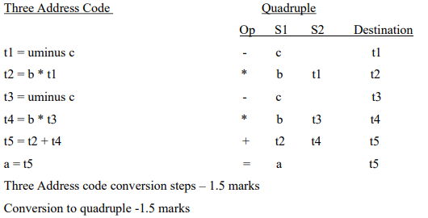
- Define SDD with an example.
Definition – 2 marks
Example - 1 mark
Syntax directed definition specifies the values of attributes by associating semantic rules with the grammar productions. It is a context free grammar with attributes and rules together which are associated with grammar symbols and productions respectively.
Eg:
E-> E1 + T { E.val = E1.val + T.val}

- Explain common sub expression elimination with an example.
Explanation with example – 3 marks
The expression or sub-expression that has been appeared and computed before and appears again during the computation of the code is the common sub-expression. Elimination of that sub-expression is known as Common sub-expression elimination.
1. Local Common Sub-expression elimination– It is used within a single basic block. Where a basic block is a simple code sequence that has no branches.
2. Global Common Sub-expression elimination– It is used for an entire procedure of common sub-expression elimination.
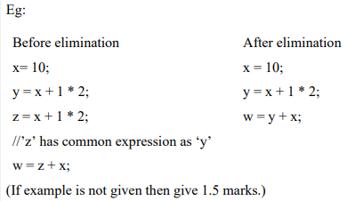

- How the peephole optimization technique makes its role in the compilation process?
Peephole optimization definition – 1.5 marks
Techniques – 1.5 marks

Peephole optimization is a type of code Optimization performed on a small part of the code. It is performed on a very small set of instructions in a segment of code.
1. Redundant load and store elimination
2. Constant folding
3. Strength Reduction
4. Null sequences/ Simplify Algebraic Expressions
5. Combine operations
6. Dead code Elimination
(Write Any three methods)

PART B

11 a
Phases – 4 marks
Explanation using the given example – 4
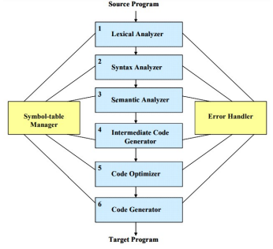
Lexical Analysis
- The first phase of a compiler is called lexical analysis or scanning or linear analysis.
- The lexical analyzer reads the stream of characters making up the source program and groups the characters into meaningful sequences called lexemes.
- For each lexeme, the lexical analyzer produces as output a token of the form
<token-name, attribute-value>
For example, if a source program contains the assignment statement position = initial + rate * 60
- Blanks separating the lexemes would be discarded by the lexical analyzer. The sequence of tokens produced as follows after lexical analysis.
<id, 1> <=> <id, 2> <+> <id, 3> <*> <60>
Here,
- id is an abstract symbol standing for identifier.
- 1,2 and 3 are points to the symbol table entries for position, initial and rate respectively.

- +,= and * are abstract symbols for addition, assignment and multiplication operators. They do not need any attribute-value.
- 60 is a lexeme that is mapped into the token <60>.

Syntax Analysis
- The second phase of the compiler is syntax analysis or parsing or hierarchical analysis.
- The parser uses the tokens produced by the lexical analyzer to create a tree-like intermediate representation that depicts the grammatical structure of the token stream.
- The hierarchical tree structure generated in this phase is called parse tree or syntax tree.
- In a syntax tree, each interior node represents an operation and the children of the node represent the arguments of the operation.
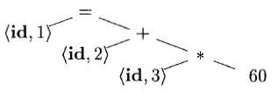


Semantic Analysis
- The semantic analyzer uses the syntax tree and the information in the symbol table to check the source program for semantic consistency with the language definition.
- It also gathers type information and saves it in either the syntax tree or the symbol table, for subsequent use during intermediate-code generation.
- Eg: The operator * is applied to a floating-point number rate and an integer 60. The integer may be converted into a floating-point number by the operator inttofloat explicitly as shown in the figure below
- 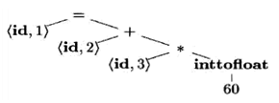
- Fig: Semantic tree for position = initial + rate * 60
Intermediate Code Generation
- After syntax and semantic analysis of the source program, many compilers generate an explicit low-level or machine-like intermediate representation.

- Three-address code is one of the intermediate representations, which consists of a sequence of assembly-like instructions with three operands per instruction.
- The output of the intermediate code generator consists for position = initial + rate * 60 is given below:
t1 = inttofloat(60)
t2 = id3 * t1
t3 = id2 + t2
id1 = t3
Code Optimization
- Code optimization phase attempts to improve the intermediate code so that better target code will result.
- Better means faster, shorter etc.
- Eg: inttofloat operation can be eliminated by replacing the integer 60 by the floating-point number 60.0. Moreover, t3 is used only once to transmit its value to id1 so the optimizer can transform it into the shorter sequence
t1= id3 * 60.0
id1 = id2 + t1
Code Generation
- The code generator takes as input an intermediate representation of the source program and maps it into the target language.
- The intermediate instructions are translated into sequences of machine instructions that perform the same task.
- For example, using registers R1 and R2, the intermediate code might get translated into the machine code
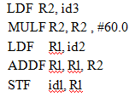
11b
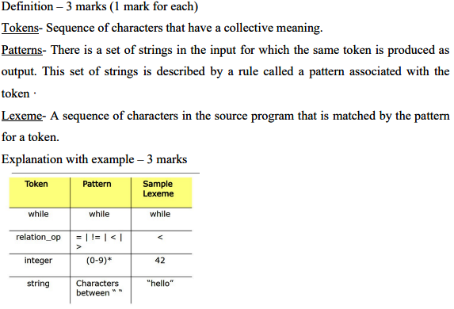
12a [6 marks]
Compiler Construction Tools
Some commonly used compiler-construction tools are given below:
- Scanner generators that produce lexical analyzers from a regular-expression description of the tokens of a language. Unix has a tool for Scanner generator called LEX.
- Parser generators that automatically produce syntax analyzers (parse tree) from a grammatical description of a programming language. Unix has a tool called YACC which is a parser generator.
- Syntax-directed translation engines that produce collections of routines for walking a parse tree and generating intermediate code.
- Data-flow analysis engines that facilitate the gathering of information about how values are transmitted from one part of a program to each other part. Data-flow analysis is a key part of code optimization.
- Code-generator generators that produce a code generator from a collection of rules for translating each operation of the intermediate language into the machine language for a target machine.
- Compiler-construction toolkits that provide an integrated set of routines for constructing various phases of a compiler.

12b
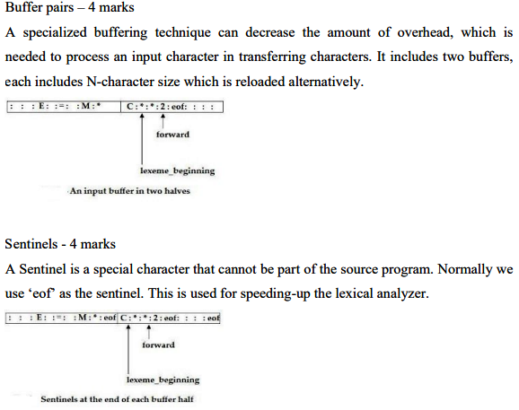
13a
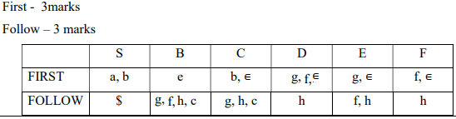

13 b
Error Recovery Strategies: (2 marks each)
- Panic Mode Recovery
- Phrase-Level Recovery
- Error Productions
- Global Correction
Panic Mode Recovery
- Simplest method used by most parsing methods.
- On discovering an error the parser discards input symbols one at a time until one of a set of synchronizing tokens is found.
- Synchronising tokens are usually delimiters such as semicolon, } etc.
- It is guaranteed not to go into an infinite loop.
Phrase-Level Recovery
- On error discovery, parser may perform local correction on the remaining input.
- It may replace a prefix of the remaining input by some string that allows the parser to continue.
- Correction maybe to replace a comma by a semicolon.
Error Productions
- Augment the grammar for the language with productions that generate erroneous constructs.
- Use the modified grammar to construct a parser.
Global Correction
- Compiler is expected to make as few changes as possible in processing an incorrect input string.
- Given an incorrect input string x and grammar G, algorithms will find a parse tree for a related string y such that the number of insertions, deletions, and changes of tokens required to transform x into y is as small as possible.

14a
Ambiguity proving - 3 marks
If the grammar produces more than one parse tree for the given input string then it is called ambiguous grammar.

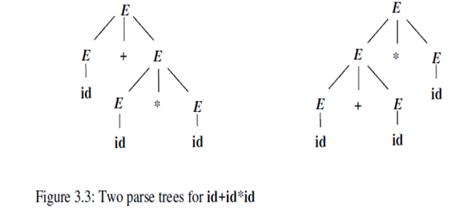
Removal – 4 marks
E-> E+T | E-T |T
T-> T * P | T/P | P
P-> P ^ F | F
F-> ( E ) | id

14b
Removing left recursion – 1 mark First -1 mark Follow – 1 mark
Parsing table – 3 marks Proof – 1 mark
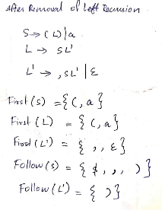
Parsing table
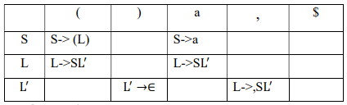

15 a Parser Explanation – 6 marks
It is a bottom-Up Parser.
It uses two data structures:
Stack - holds grammar symbols.
Input Buffer - holds the rest of the string to be parsed.
The symbol $ marks the bottom of the stack and also the right end of the input.
Initial configuration:
Stack Input
$ w$
Acceptance configuration
Stack Input
$S $
Here S is starting symbol of grammar.

Basic operations of Shift Reduce Parser:
Shift : shift the next input symbol onto the top of the stack.
Reduce: Reduce the topmost handle in the stack using appropriate production.
Accept: Announce successful completion of parsing.
Error: Discover a syntax error and call an error recovery routine.

There are two Conflicts – (2 marks each)
1. A shift-reduce conflict occurs in a state that requests both a shift action and a reduce action.
Eg:
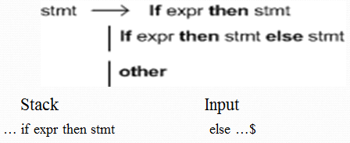

- We cannot tell whether if expr then stmt is the handle. Hence there is shift reduce conflict.

- A reduce-reduce conflict occurs in a state that requests two or more different reduce actions.
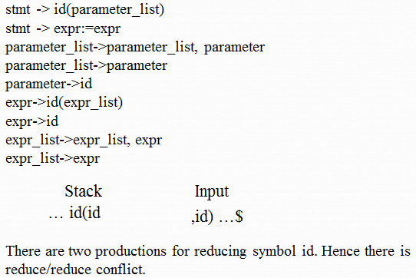
15b
Steps- 4 marks
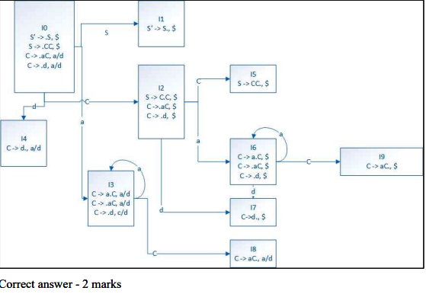
16.
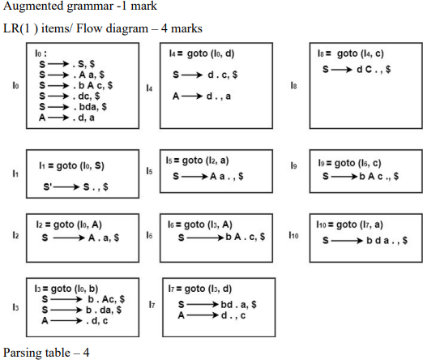
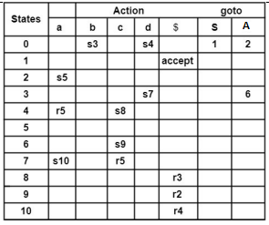
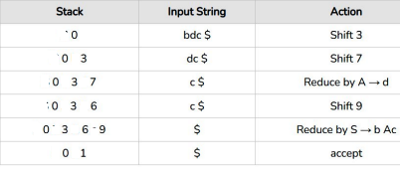

17a
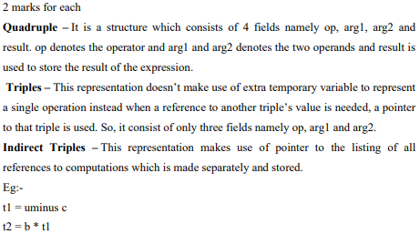
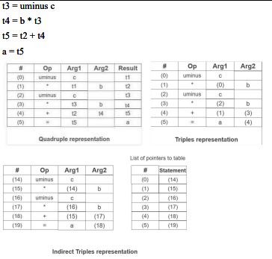
17 b

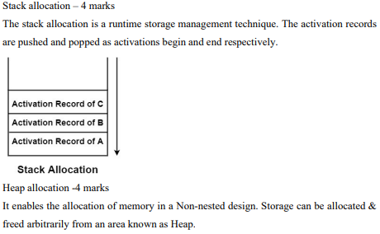
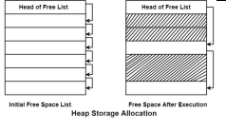

18 a
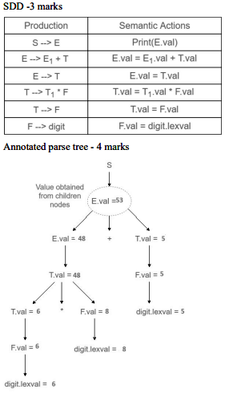

18b
Translation scheme – 3 marks Intermediate code - 4 marks
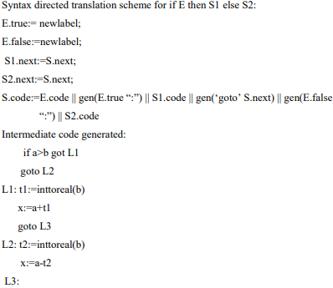

19 a
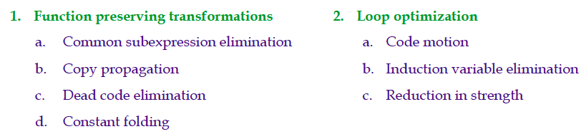Function-Preserving Transformations
- There are a number of ways in which a compiler can improve a program without changing the function it computes.
- The common function preserving transformations are:
Common subexpression elimination
Copy propagation
Dead-code elimination
Constant folding
- The other transformations come up primarily when global optimizations are performed.

Loop Optimizations:
- The running time of a program may be improved if we decrease the number of instructions in an inner loop, even if we increase the amount of code outside that loop.
- Three techniques are important for loop optimization:
  - Code Motion, which moves code outside a loop;
B) Induction-variable elimination, which we apply to replace variables from inner loop.
C) Reduction in Strength, which replaces expensive operation by a cheaper one, such as a multiplication by an addition.

19 b
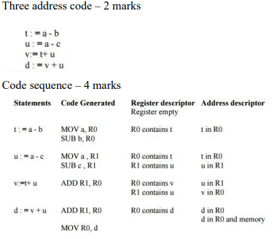
20 a
The following issues arise during the code generation phase :
1. Input to code generator
2. Target program
3. Memory management
4. Instruction selection
5. Register allocation
6. Evaluation order
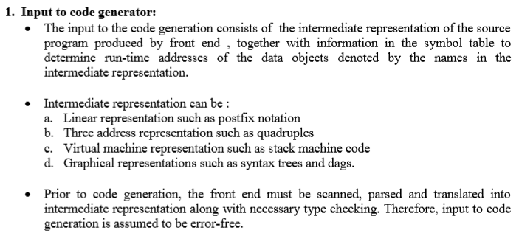
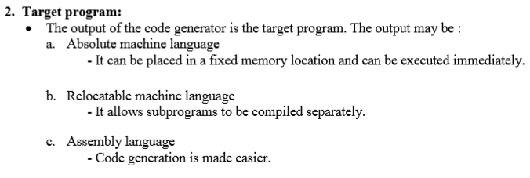
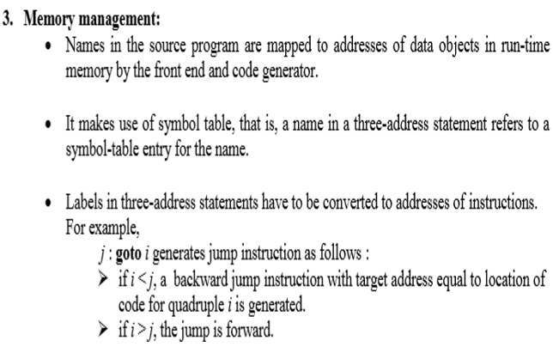
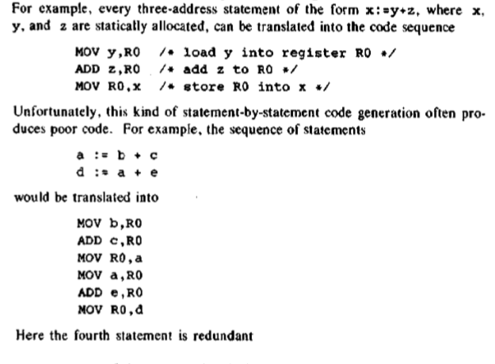
Register Allocation
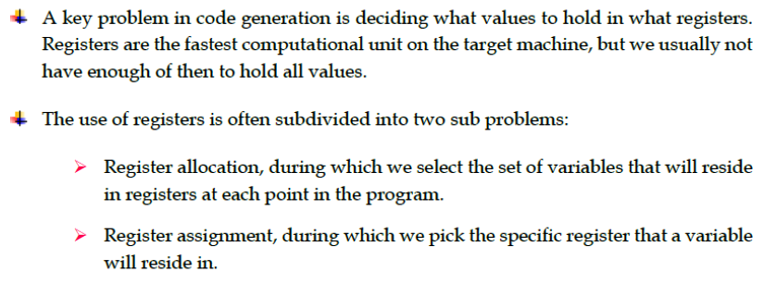
6. Evaluation order
- The order in which the computations are performed can affect the efficiency of the target code.
- Some computation orders require fewer registers to hold intermediate results than others.

20b

1. Structure preserving transformations
2. Algebraic transformations
(3.5 marks for each)
1. Structure-Preserving Transformations:
- The primary Structure-Preserving Transformation on basic blocks are:
  - Common sub-expression elimination.
  - Dead code elimination.
  - Renaming of temporary variables
  - Interchange of two independent adjacent statements.
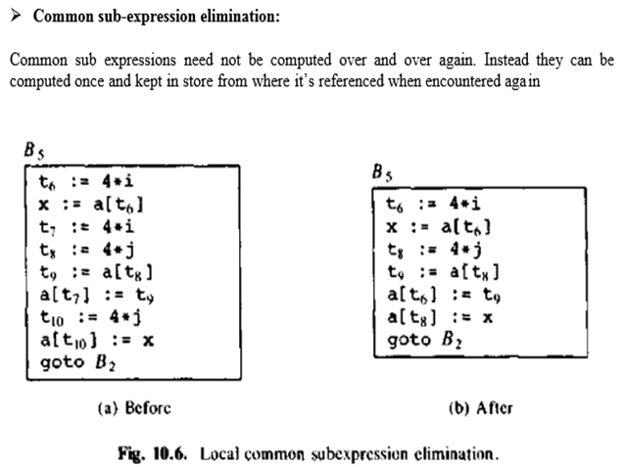
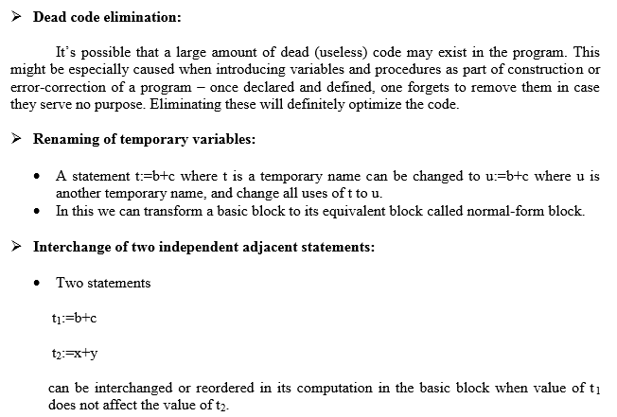
2. Algebraic Transformations
- Algebraic identities represent another important class of optimizations on basic blocks.
  - Example:
x+0 = 0+x = x
x-0 = x
x*1 = 1*x = x
x/1 = x
- Another class of algebraic optimisation includes replacing an expensive operation by cheaper ones i.e. reduction in strength.
  - Example:
x ** 2 = x*x
2.0*x = x+x
x/2 = x*0.5
- Another class of algebraic related optimizations is constant folding.
  - Here we evaluate constant expressions at compile time and replace the constant expressions by their values.
  - Thus the expression 2*3.14 would be replaced by 6.28.

